**Liberty University**

**CSIS 331**

**Lab 8 Instructions**

**Packet Tracer:**

*[Adapted from Cisco Networking Academy Routing and Switching 1.1.1.8]*

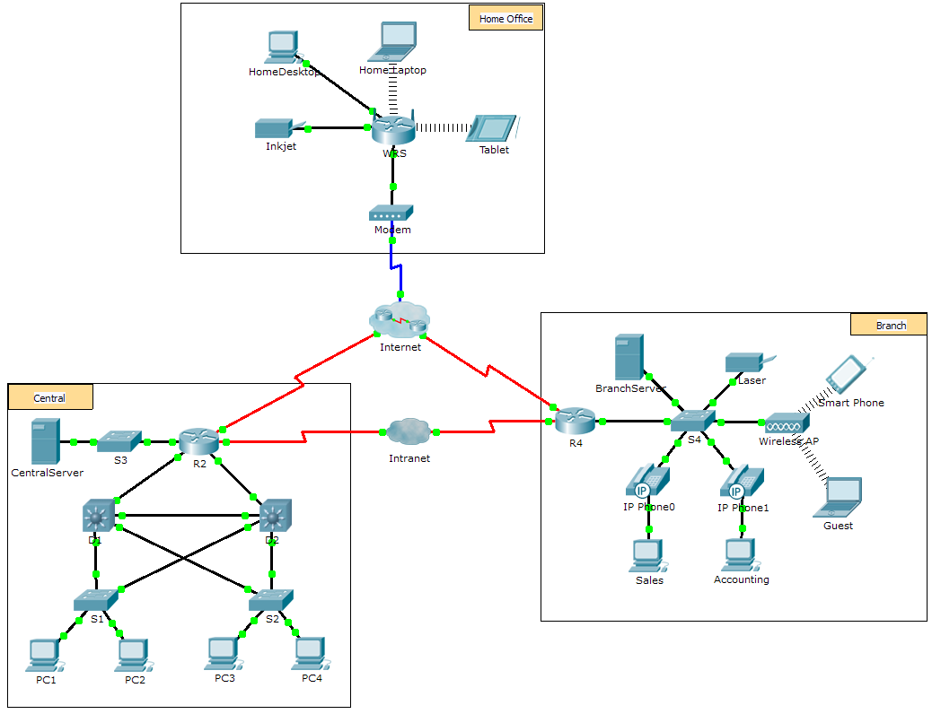

1. Scenario

The company you work for has acquired a new branch location. You asked for a topology map of the new location, but apparently one does not exist. However, you have username and password information for the new branch’s networking devices and you know the web address for the new branch’s server. Therefore, you will verify connectivity and use the **tracert** command to determine the path to the location. You will connect to the edge router of the new location to determine the devices and networks attached. As a part of this process, you will use various show commands to gather the necessary information to finish documenting the IP addressing scheme and create a diagram of the topology.

**Note**: The user EXEC password is **cisco**. The privileged EXEC password is **class**.

1. Trace and Document a Remote Location

**Note:** As you complete the following steps, copy command output into a text file for easy reference and record the missing information in the **Addressing Scheme Documentation** table.

Refer to the **Hints** page for a review of the commands used. In Packet Tracer, click the right arrow (>) on the bottom right side of the instruction window. If you have a printed version of the instructions, the **Hints** page is the last page.

* + 1. Click **Sales** and the **Desktop** tab > **Command Prompt**. Use the **ipconfig** command to check the IP address configuration for **Sales**.
    2. The new server web address is **b2server.pt.pka.** Enter the following **nslookup** command to discover the IP address for **b2server**:

PC> **nslookup b2server.pt.pka**

**Answer Question 1 on the Answer Sheet.**

* + 1. Enter the **tracert** command to determine the path from **Sales** to **b2server.pt.pka**.

PC> **tracert b2server.pt.pka**

* + 1. Telnet to the first IP address in the **tracert** output and log in.

PC> **telnet 172.16.0.1**

* + 1. You are connected to the **R4** router. Issue the **traceroute** command on the router using the address for b2server determined in step b. **Answer Question 2 and 3 on the Answer Sheet.**
    2. Use the show ip interface brief command to display the status of the interfaces on R4**. Answer Question 4 on the Answer Sheet.**

Hint: Use **show running-config** to view the subnet mask values for the interfaces.

* + 1. Telnet to the second IP address in the **tracert** list and log in. You can use the number in the far left column of the **tracert** output to track where you are in the list. **Answer Question 5 on the Answer Sheet.**
    2. Issue the **show ip route** command and study the output. **Answer Question 6 and 7 on the Answer Sheet**. NOTE: The next consecutive letter i is missing intentionally.
    3. Telnet to the third IP address in the **tracert** list and log in. **Answer Question 8 on the Answer Sheet.**

Issue the **show ip route connected** command. **Answer Question 9 on the Answer Sheet.**

Refer to the **Addressing Table**. **Answer Question 10 on the Answer Sheet.**

* + 1. Telnet to the fourth IP address in the **tracert** list and log in **Answer Question 11 on the Answer Sheet.**

Issue a command to determine to what interface **b2server.pt.pka** is connected **Answer Question 12 on the Answer Sheet.**

* + 1. If you have used the **Address Table** as you completed the previous steps, the table should now be complete. **If not, finish the table on your Answer Sheet.**
    2. With a complete documentation of the addressing scheme and knowledge of the path from **Sales** to **branch2.pt.pka**, you should be able to now **draw the new branch location in the Topology Documentation on your Answer Sheet**.

1. Address Table

|  |  |  |  |  |
| --- | --- | --- | --- | --- |
| Trace Route ID | Device | Interface | Address | Subnet Mask |
| - | Sales | NIC | 172.16.0.x (DHCP) | 255.255.255.0 |
| 1 |  |  |  |  |
|  |  |  |
| S0/0/1.1 | 64.100.200.1 | 255.255.255.252 |
| 2 |  |  |  |  |
| G0/1 | 64.104.223.1 | 255.255.255.252 |
| S0/0/0 | 64.100.100.2 |  |
|  |  |  |
| 3 |  |  |  |  |
| G0/2 |  | 255.255.255.0 |
| F0/1 | 128.107.46.1 |  |
|  |  |  |
| 4 |  | G0/0 |  |  |
|  |  |  |
| 5 | b2server.pt.pka | NIC | 128.107.64.254 | 255.255.255.0 |

1. Hints - Command Summary Reference
2. DOS Commands

**ipconfig** - The output of the default command contains the IP address, network mask and gateway for all physical and virtual network adapters.

**ipconfig /all** - This option displays the same IP addressing information for each adapter as the default option. Additionally, it displays DNS and WINS settings for each adapter.

**Nslookup** - Displays information that you can use to diagnose Domain Name System (DNS) infrastructure.

Syntax:

nslookup dns.name

**Tracert** - Determines the path taken to a destination by sending Internet Control Message Protocol (ICMP) Echo Request messages to the destination with incrementally increasing Time to Live (TTL) field values. The path displayed is the list of near-side router interfaces of the routers in the path between a source host and a destination. The near-side interface is the interface of the router that is closest to the sending host in the path. Used without parameters, tracert displays help.

Syntax:

tracert [TargetName/IP Address]

1. IOS Commands

**show ip interface** – Displays the IP interface status and configuration

**show ip interface brief** – Displays a brief summary of IP status and configuration

**show ip route** – Displays the full IP routing table

**show ip route connected** – Displays a list of active directly connected networks

**show running-config** – Displays the current operating configuration

**traceroute** – Trace route to destination